**Host a Website in S3**

Replace example.com with you bucket name

Step 1: Create Bucket

1. Sign in to the AWS Management Console and open the Amazon S3 console at[https://console.aws.amazon.com/s3/.](https://console.aws.amazon.com/s3/)
2. Click **Create Bucket**.
3. In the Create Bucket dialog box, in the Bucket Name box, type a name for your bucket.

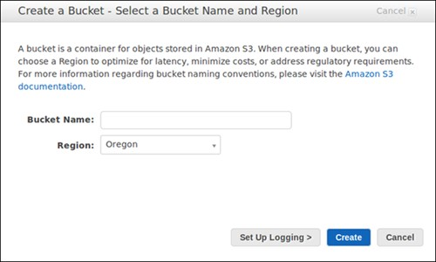

1. In the **Region** box, click the region where you want the bucket to reside.
2. Click Create

**Step 2: Change Bucket policy to host website**

1. In the Buckets list, click the bucket whose properties you want to view and Click on Permission and click Bucket Policy

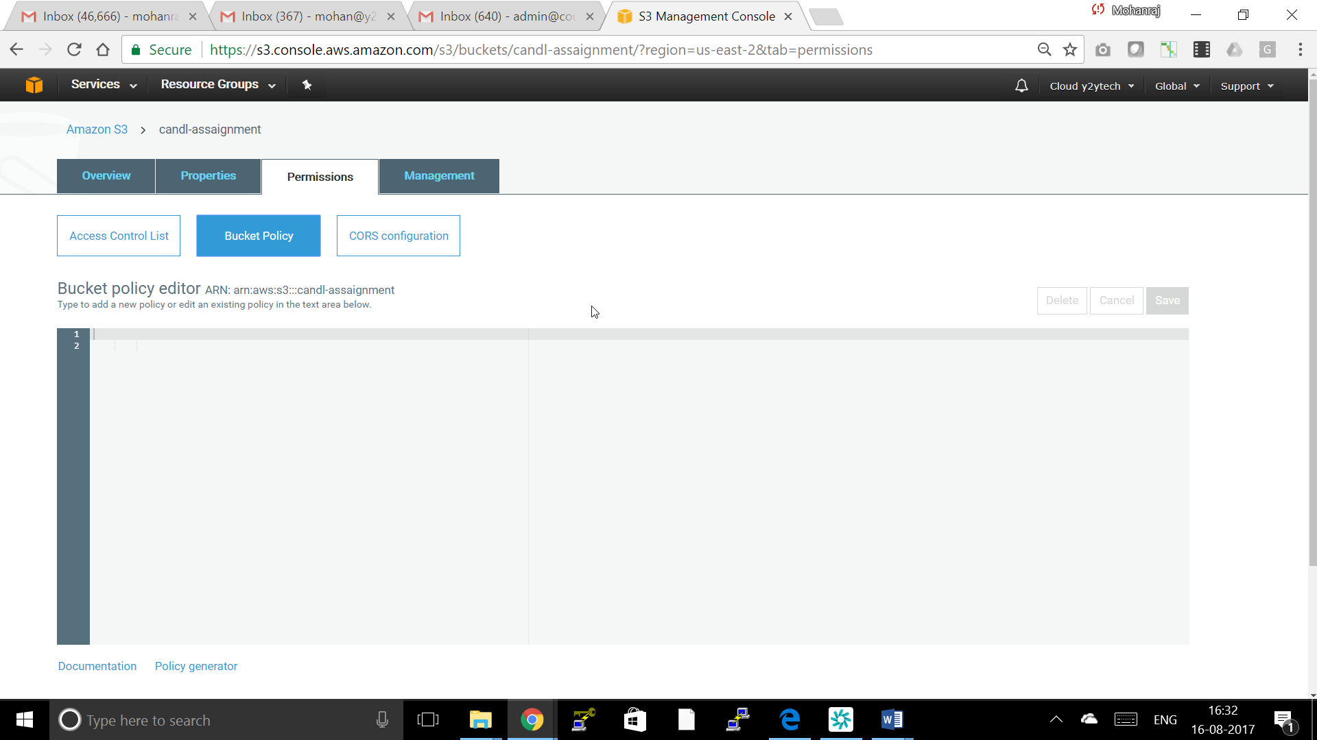

Step 3: Upload your website data to the *example.com* bucket.

**Step 4: configure *example.com* bucket for website hosting**

In the Buckets pane, click the Properties and click **Static Website Hosting**.

Click **Use this Bucket to Host website**.

In the **Index Document** box, type the name of the index document Example index.html

Optionally, in the **Error Document** box, you can also provide the name of a custom error document click **Save**.

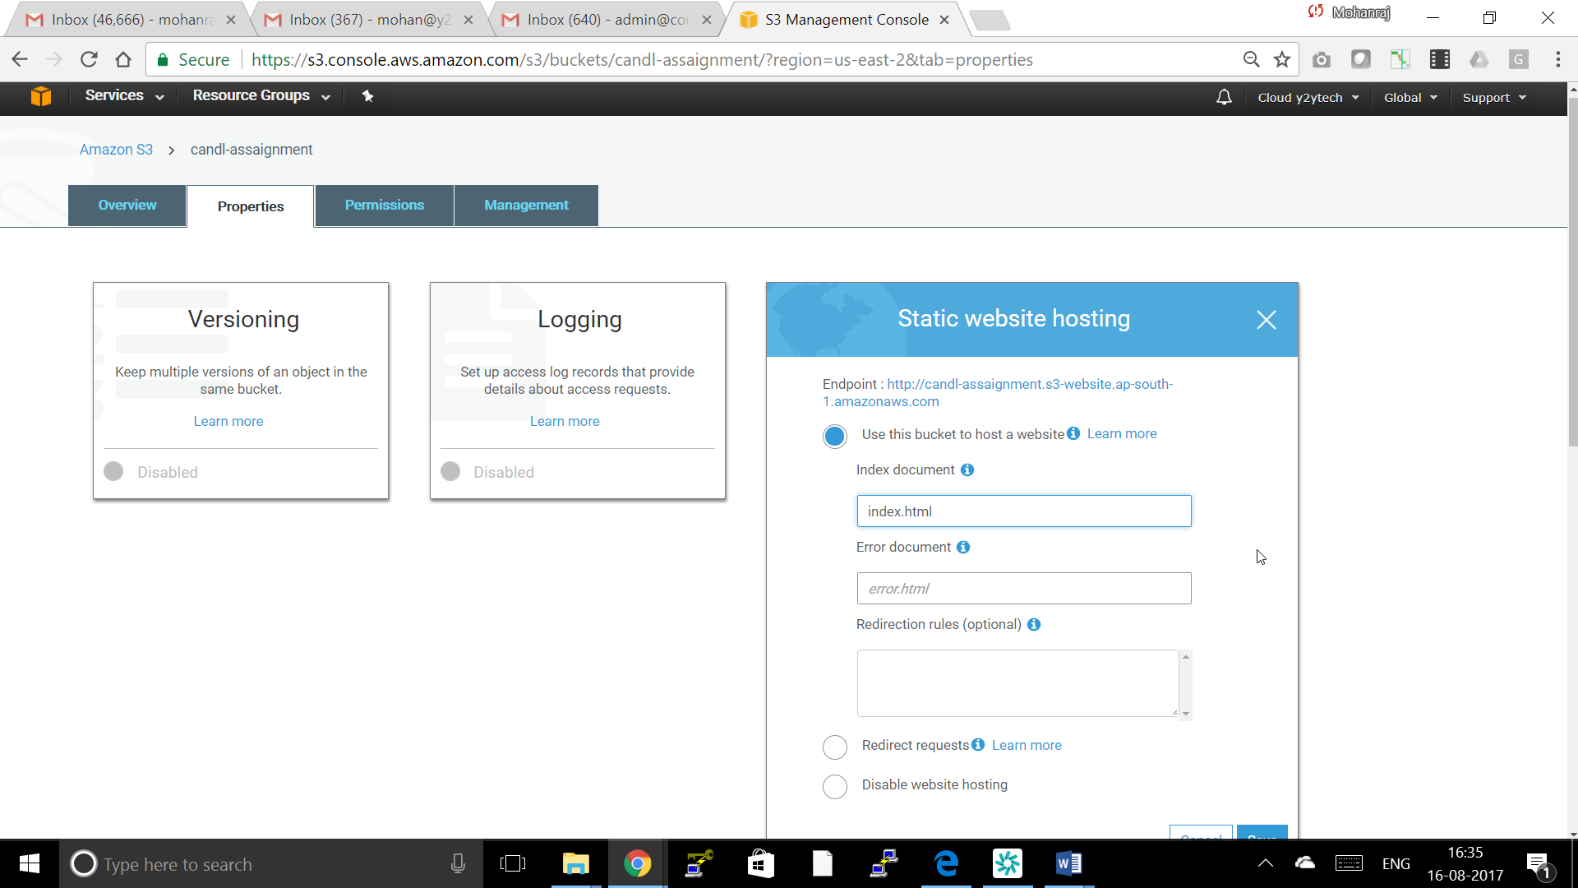

Step 5: Validate by Opening browser and type the url to access the Website

[*http://example.com*.s3-website-us-east-1.amazonaws.com](http://example.com.s3-website-us-east-1.amazonaws.com/)